# Lab 19

Instructor: Sidra Khatoon

E-mail: skhatoon[@uit.edu](mailto:ad@uit.edu)

# Objective

# The objective of lab is to Fetch Data from an API and display It in ListView in Flutter

**Student Information**

|  |  |
| --- | --- |
| **Student Name** |  |
| **Student ID** |  |
| **Date** |  |

**Assessment**

|  |  |
| --- | --- |
| **Marks Obtained** |  |
| **Remarks** |  |
| **Signature** |  |

# Objective

# The objective of lab is to Fetch Data from an API and display It in ListView in Flutter

# Instructions

You have to perform the following tasks yourselves. Raise your hand if you face any difficulty in understanding and solving these tasks. **Plagiarism** is an abhorrent practice and you should not engage in it.

# How to Submit?

Submit lab work using Teams.

# How to Fetch Data from an API and Display It in ListView in Flutter?

Any modern app nowadays has a basic requirement of fetching data from some API. In flutter, it is quite

easy to do so. The basic idea to implement fetching and displaying data from REST API goes like this.

* Write a method to fetch data from the API
* Calling that method gives us an API response (JSON)
* Create a model class for the JSON response (we will need this to parse our JSON response to a dart object)
* Create a ListView builder wrapped inside a future builder (we will discuss this pattern further).
* Pass dart object details into the ListView builder

# Get dependencies

Start by adding the http dependency in your pubspec.yaml. We will need this to make the get call.

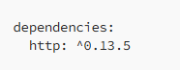

Then import the following into your project.

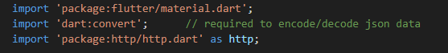

**Our API for JSON response**

For this example, we will be using jsonplaceholder

API :

<https://jsonplaceholder.typicode.com/albums/1/photos>

The API response from this is as below —

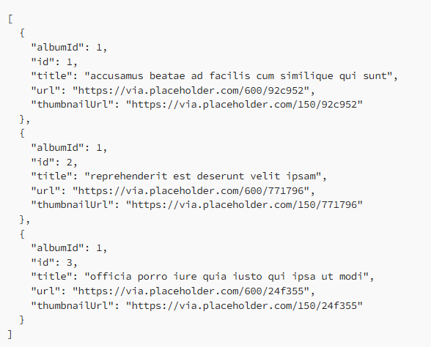

This API returns a list of photos. Each entry contains album Id, Id, title, url, and thumbnail url.

**Model class**

We need a model class to convert this JSON response to a dart object. Create a new dart file. We’ll name it post.dart.

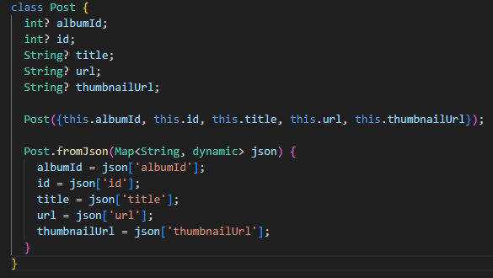

In the model class, we mention all the fields. In our case, it is albumId, id, title, url, thumbnailUrl. Also notice that we have a method Post.fromJson . This method will map the JSON keys into our model class’s fields.

**Function to call the API**

Now let's write a function getPosts() to fetch data from our API.

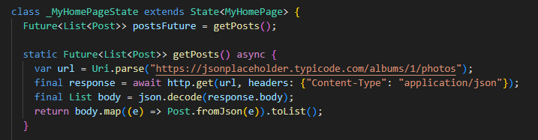

This function returns Future<List<Post>>. Future in dart is anything, data in our case, that will be available to us after some time (in future). So, this function will return, in future, a list, and each element in that list is of type Post and hence Future<List<Post>> .

Let's save this list of posts into a variable



**FutureBuilder**

Now that we have a Future List of data (posts), let's take care of displaying it on the screen. For this, we will use FutureBuilder and inside of that, we will put ListView Builder.

FutureBuilder, as explained earlier will build on the data that will be available asynchronously in future. A FutureBuilder requires two parameters: future (we have this already from our above function that returns Future List of posts) and builder (this is where we will do stuff with our API data). Following is a basic structure of FutureBuilder.

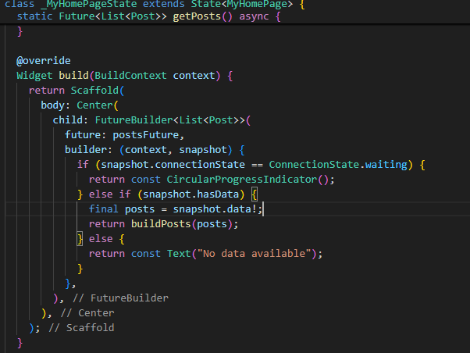

**Function to actually display the data**

Notice that if the snapshot has the data, then, we call a function buildPosts(). Here is the buildPosts function.

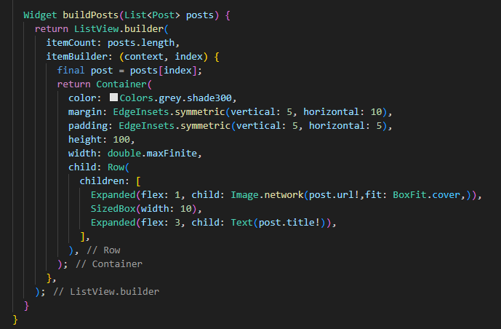

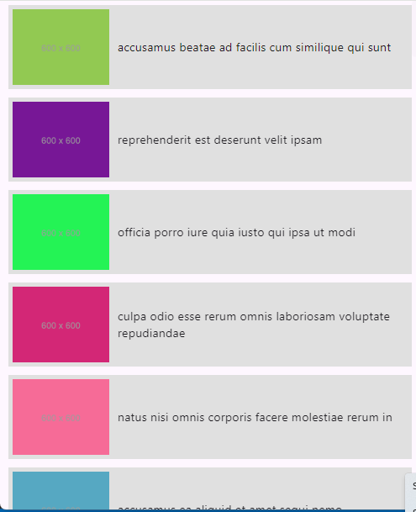

If error occurs run this in terminal:

flutter run -d chrome --web-renderer html

**Assessments:**

1. How do you fetch data from an API in Flutter?
2. What is the role of the http package in Flutter for API calls?
3. How do you parse JSON data in Flutter?
4. What is a FutureBuilder in Flutter, and how is it used with API data?